# **Rajnish Kumar Verma**

**205121078**

**MCA – 2024**

**Final Year Project Design**

# **Design of the NFT Marketplace**

1. **Close to 20-25 Page (Component) and 10-15 pages will be there will be Involved.**
   1. **Navigation Component**
   2. **Footer Component**
   3. **Slider Component**
   4. **Button Component**
   5. **Hero Section Component**
   6. **Service Component**
   7. **Big Slider Component**
   8. **Subscribe Component**
   9. **Title Component**
   10. **Category Component**
   11. **Filter Component**
   12. **NFT Card Component**
   13. **Collection Component**
   14. **Follower Component**
   15. **Audio Card Component**
   16. **Brand Component**
   17. **Video Component**
   18. **Author Component**
   19. **Search Component**
   20. **NFT Details Component**
   21. **Account Component**
   22. **Connect Wallet Component**
   23. **Contact us Component**
   24. **About us Component**
   25. **Price Component**
   26. **…………………..**

**Design of Home Page**

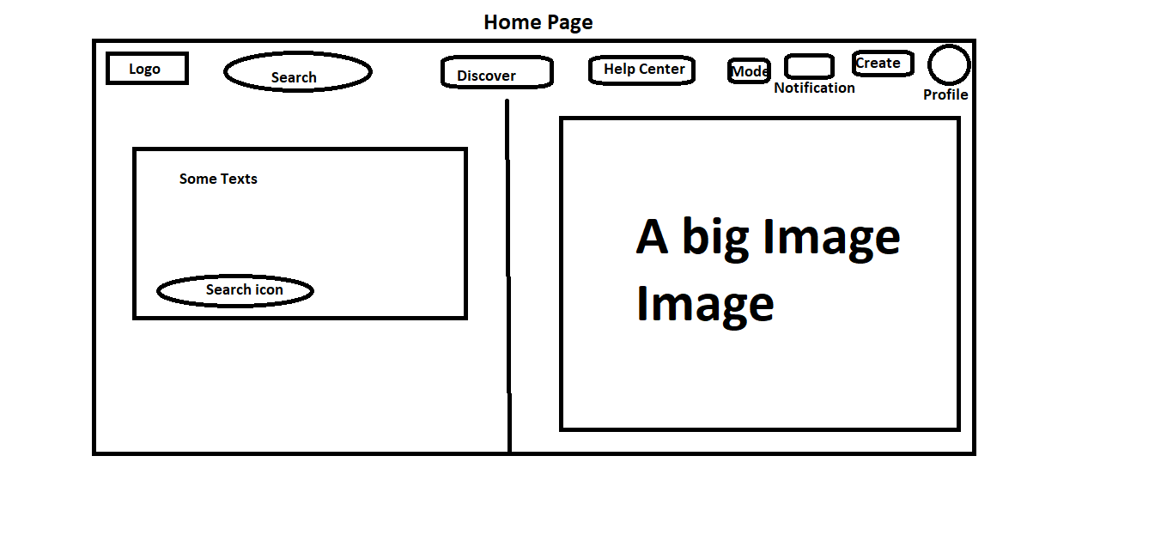

**Search Page**

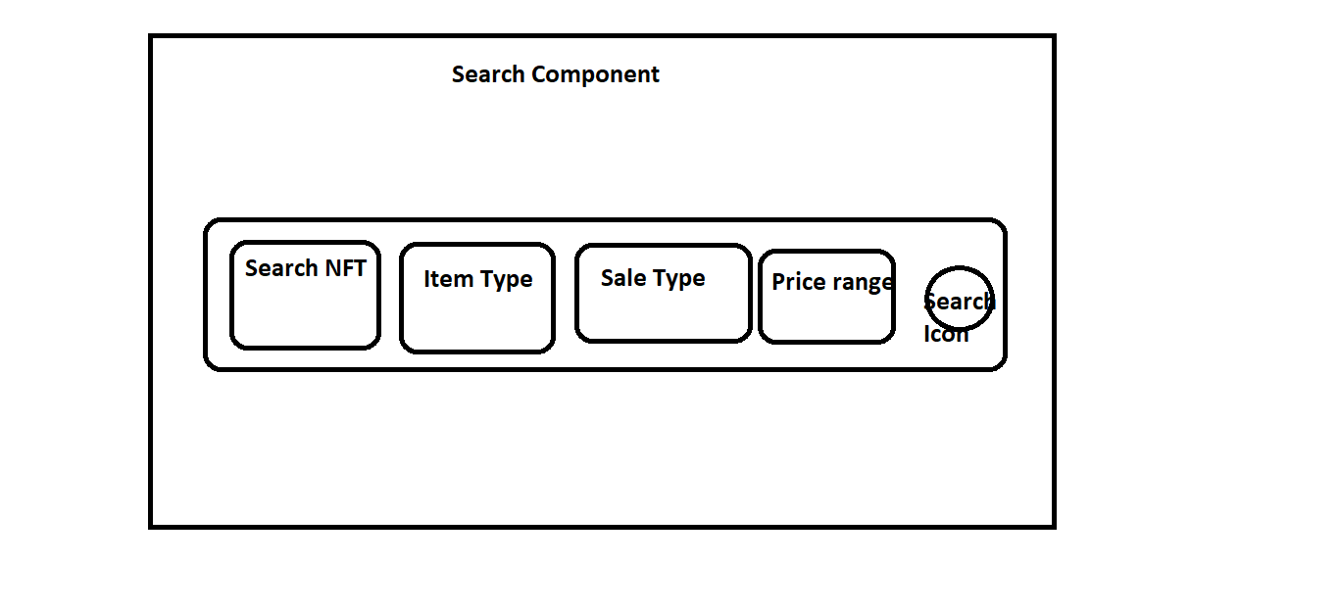

**Service Component**

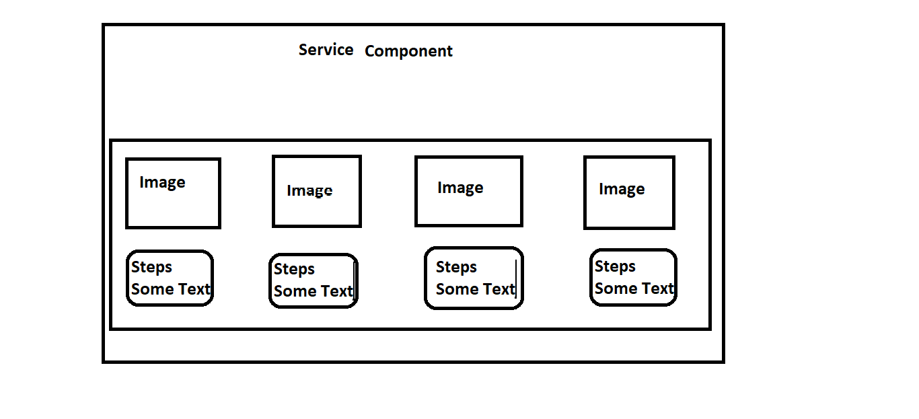

**NFT Card Page**

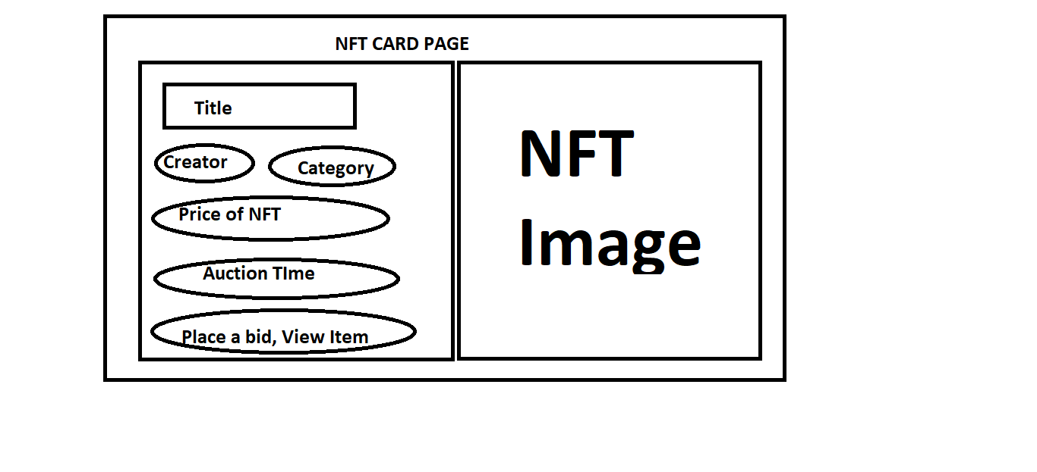

**Audio Card Component**

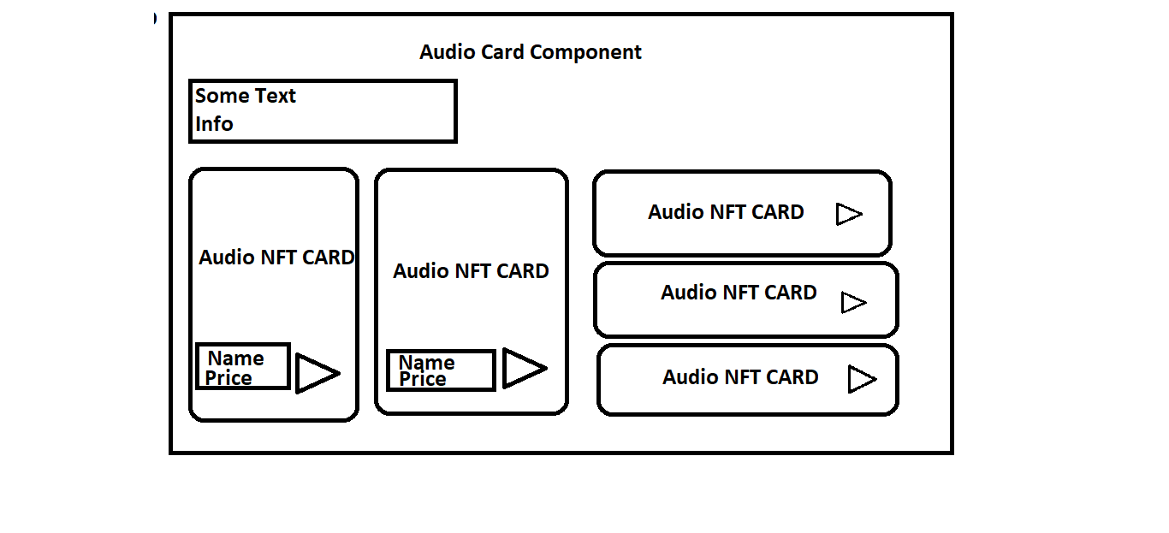

**Creator Car0**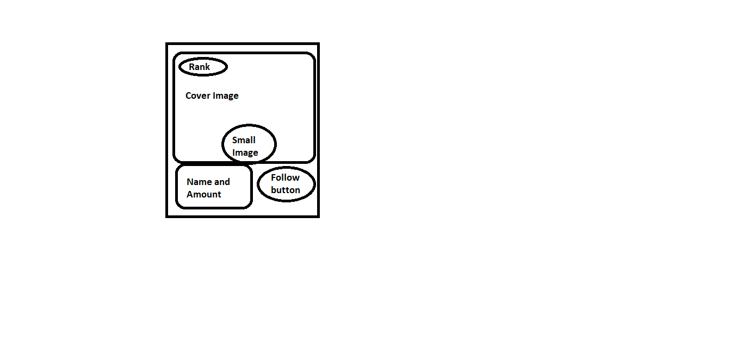

**Creator List Page**

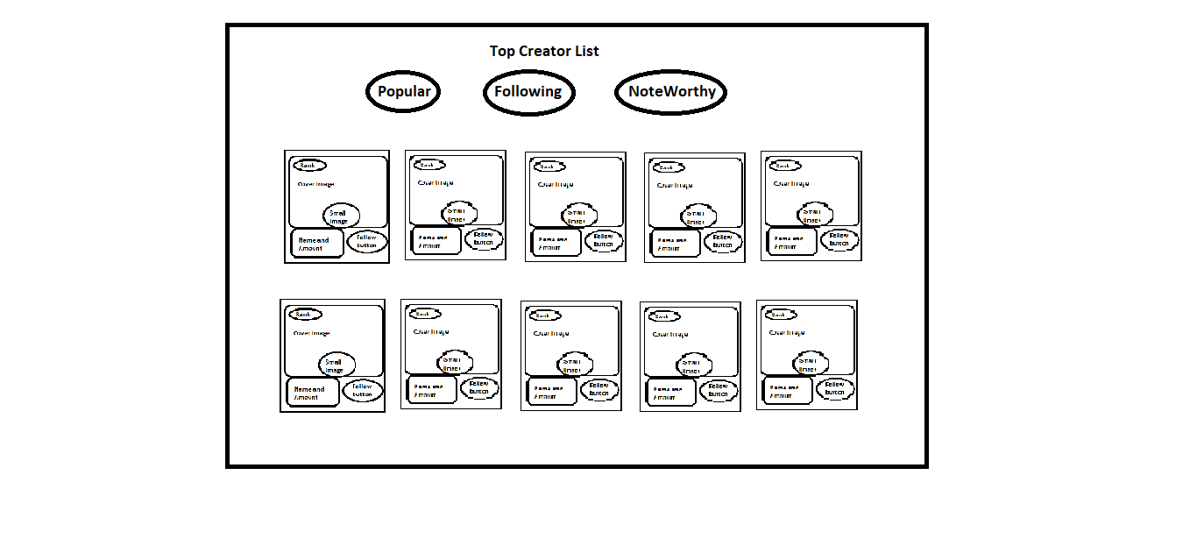

**Video card page**

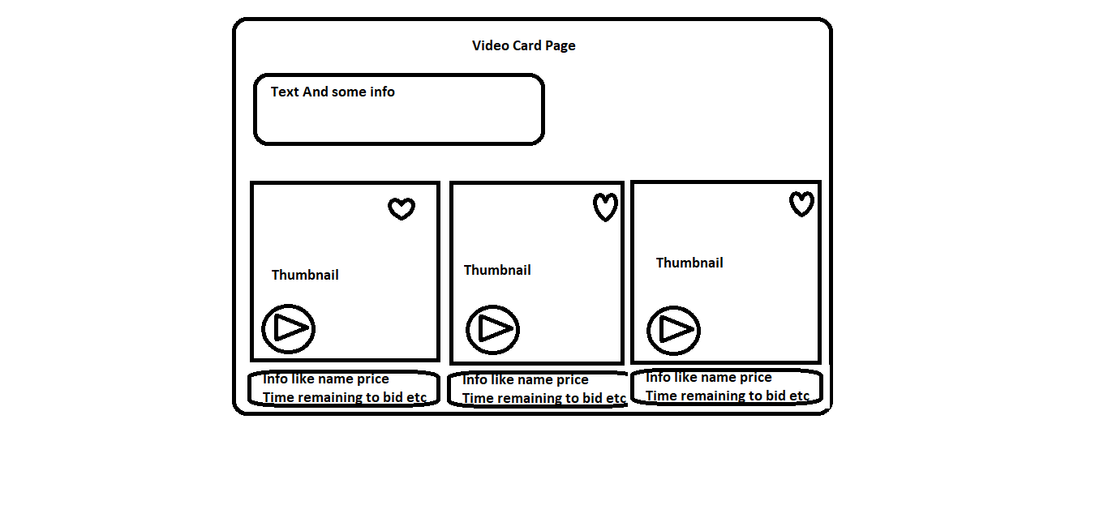

**Login Page**

**Login Using Email and Password**

**Right now**

**Sign Up Page**

**Using Email Password**

**Subscription**

**Based on Three Prices**

1. **$ 5/month**
2. **$ 15/month**
3. **$ 25/month**

**About us Page**

**Just Normal Info, I design like simple page**

**An image and info (Content)**

**Like that**

**Contact us**

**Divide into to page**

**Left side our Website info Address, Contact, etc,**

**Right Side Given a form like Full Name, Email, Message**

**Connect Wallet Page**

**Option like**

**Metamask**

**Walletconnect**

**Walletlink**

**Formatic**

**Create a NFT Page**

**Form With Info like**

1. **Image, Audio, Video, 3D Model**
2. **Item Name**
3. **Links**
4. **Description**
5. **Collection Category**
6. **Size, Price**
7. **Properties**
8. **Enable on sales option**
9. **Enable for bidding**
10. **Etc….**